**My understanding of dataset**

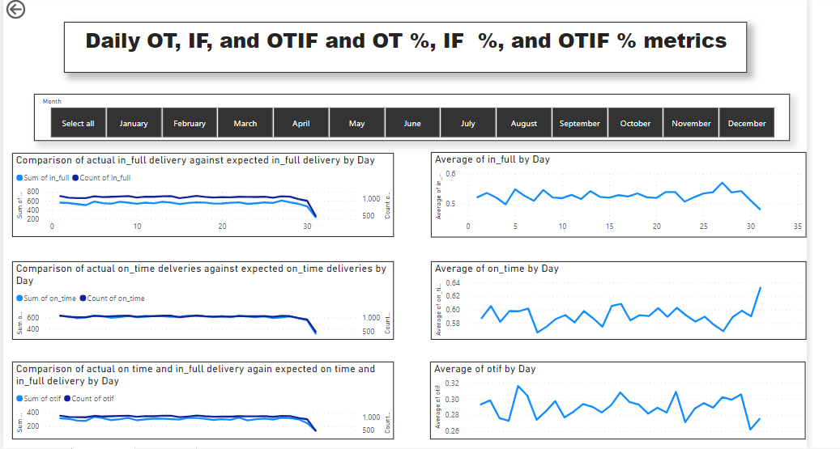

The dashboard created is helpful in understanding day wise are we able to deliver the products on time and fully. If not what is the difference that we are seeing. As our understanding we were never able to achieve 100% any day in providing desired service.   
Also Average in_full, on_time and on_time_in_full metrics on daily basis gives overall target reached per day. There is need I improving the service in both domain i.e., delivering the product fully and delivering the products on time. Atliq Mart which is responsible for delivery can improvise it’s service in terms of on time delivery and B-Mart should take care of the full_delivery concern since this issue might due to quantity issues.

For better understanding I have given filter on Month to select as we had all the data belonging to Year 2022. By opting the month we can understand the metric better month wise and day wise. Considering all months during mont end the full delivery seems to be performing low while on time delivery is improved.

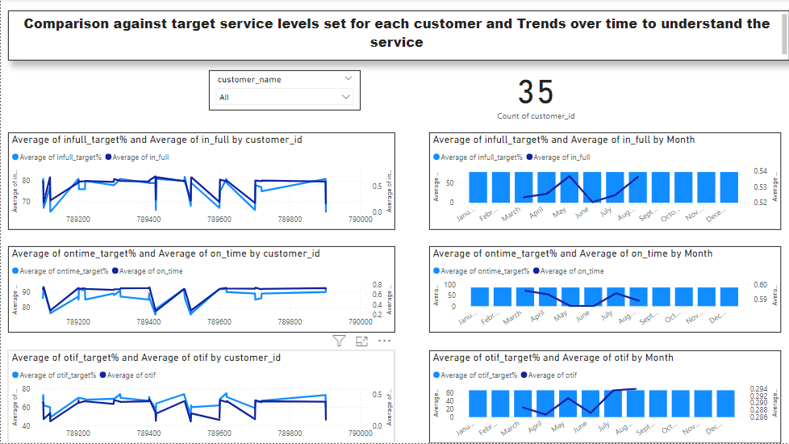

This report will allow us to understand the performance of service levels for each customer. Since we have total 35 distinct customers, and would be difficult to understand all at one place. There is slicer for filtering out according to customer name, which in turn will also give us count of number of customers we have for that customer name, that is being displayed using score card. This will gives us comparison between what is the target level of service set for each customer and what is he average of service that is being provided.

Also the other graph on right side shows the bar graph indicating average target set over time and the average of actual service done over period. Over period there is improvement in delivering the products fully. Where as there is decrement in delivering the items on time.

The areas of concern are both. Before expanding the business, As per our finding. It would be better if they could work on delivering the products fully and on time and with no or slight variation between target %. Since as of now , as per data provided we could see there is lot of difference and is not performing as per expectation.

Also I have created new table called data_collection as per requirement and in column delivered items it shows the item name nly if the products are delivered fully i.e., in full quantity else it shows values as Partial_delivery.

To set the alert to notify the particular department by setting sthe threshold, I am unable to see the option in my Power-BI application may be sue to version problem. I have done the report as per my understanding and I acknowledge that it has be done on my own. PFB pbix file for same.